1. **The dependency diagram in Figure 1 indicates that authors are paid royalties for each book that they write for a publisher. The amount of the royalty can vary by author, by book, and by edition of the book.**

**Figure 1: Book royalty dependency diagram**

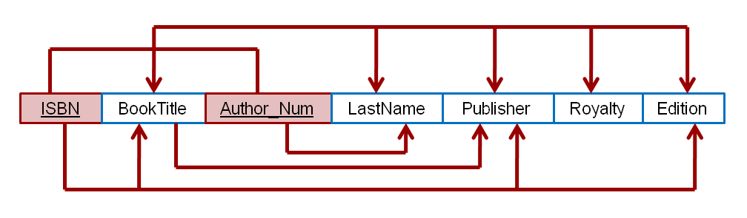

* 1. **Based on the dependency diagram in Figure 1, create the dependency diagram in 2NF.**

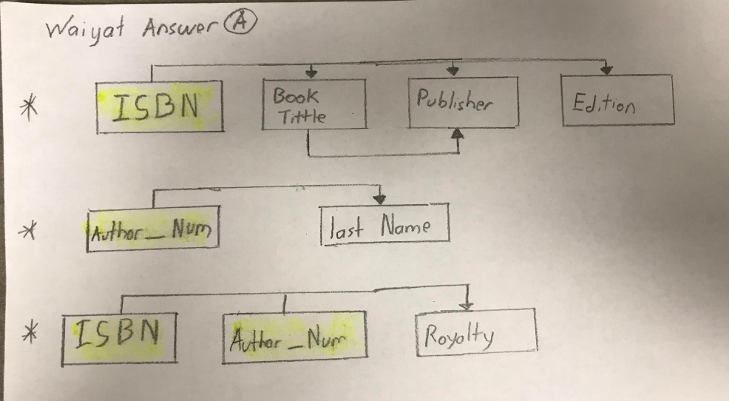

* 1. **Based on the dependency diagram in Figure 1 and your 2NF diagram, create the dependency diagram in 3NF.**

